Lecture 1. C Programming Language

* Developed at AT&T Laboratories in 1972 by Dennis Ritchie for the UNIX operating system
* Building block for many known programming languages
* Used for:
  + Operating systems
  + Compilers
  + Assemblers
  + Editors
  + Network drivers
  + Utilities
  + Embedded systems
  + General-purpose programs

## Features of C programming language

* C is a structured programming language
* C is highly portable language – C program is platform independent. This applies to both, choice of operating system and hardware platform.
* C brings together the features of high-level programming languages and the bit manipulation capability.
* C is fast – Compilation and execution are faster than with most other programming languages.
* C can extend itself by adding functions to its collection of build-in functions.
* C is easy to learn – It has only 32 keywords.

# Structure of a C program

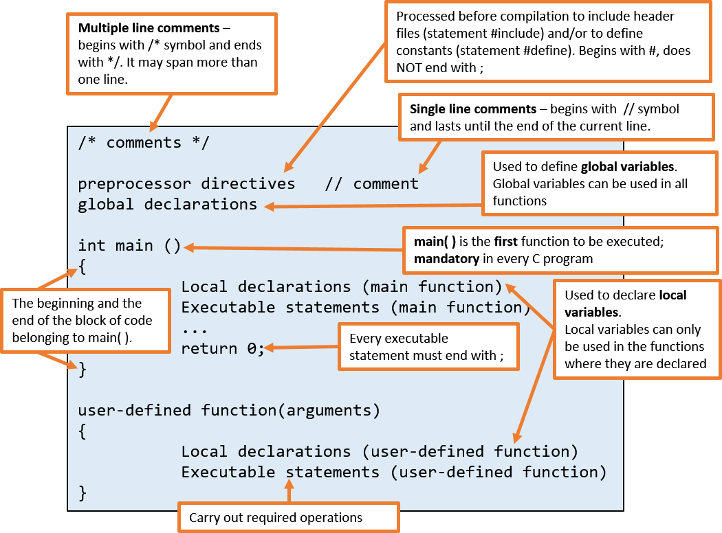

* Comments are optional; they are ignored by the compiler
* Preprocessor directive #include is used to access header files (files with extension .h) which contain a set of macro definitions and declarations of common C functions (build-in function). The actual executable code is stored in C libraries.
* It can be **only one** main( ) function in every C program.
* Global/local declarations state the program’s need for memory.
* { } are used to group statements together and to define the body of the function. For every open bracket {, there must be a closing bracket }.
* Statement **return 0;** is used to end the program and to return 0 to the operating system indicating normal termination. Non-zero value indicates abnormal termination and it is usually 1.
* C is case-sensitive language

# C Language Elements

### C Character Set

|  |  |
| --- | --- |
| Alphabets | Uppercase: A – Z  Lowercase: a –z |
| Digits | 0 – 9 |
| Special characters | - ~ ‘ ! @ # % ^ & * ( ) _ - + = | \ { } [ ] : ; " ' < > , . ? / |
| White space characters | blank space, new line, horizontal tab, carriage return, form feed |

C Keywords (Reserved Words)

* All keywords are in lowercase letters
* Cannot be used for identifiers (user-defined names)

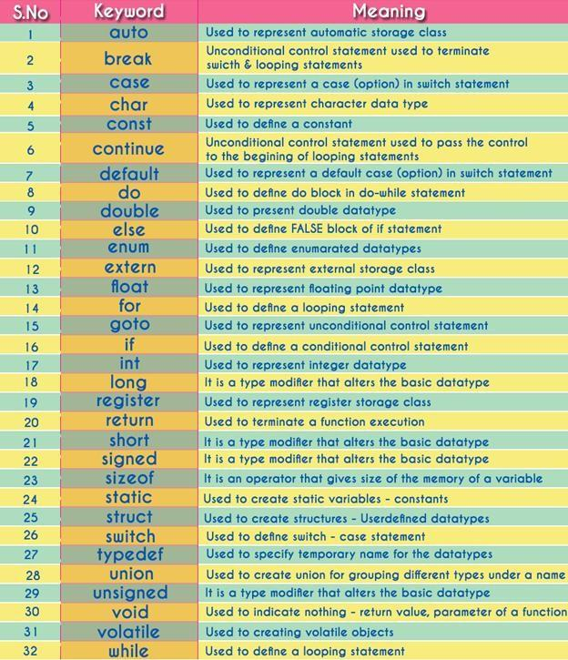

“32 Keywords in C Programming Language with their Meaning.” n.d. Online Image. BSC btechsmartclass. 23 Jan, 2017. <http://www.btechsmartclass.com/CP/c-keywords.htm>

### Identifiers

Identifier is a user defined name given to variable, function, constant and/or other program entity.

Rules for creating identifiers:

* Identifiers are case sensitive (varName is not the same as varname)
* Can only consist of letters (uppercase and lowercase), digits, and underscore (_)
* Cannot start with a digit (0-9)
* Underscore can be used as the first character (example: _result)
* Cannot contain any special character other than underscore (_)
* Cannot use reserved words (keywords)
* The identifier length limit is compiler dependent.
* Given names should be descriptive, meaningful, and unique.

# Function printf()

printf() is a build-in C function used to perform output operations such as displaying data on the screen, sending data to printer or file.

printf() is defined in “stdio.h” header file. When printf() is used in the program, the “stdio.h” header must be included as follows:

**#include<stdio.h>**

Syntax: **printf(“*format_string”, variable1, variable2, variable3, ...*);**

where

***format_string*** is a string that can contain 3 types of elements:

* Plain characters that will be displayed on the screen (unchanged)
* **Format specifiers** (conversion specifiers) used as placeholders, which will be replaced by the values of variables listed after the *format_string*.
  + Format specifier begins with %, followed by the data type code. Data type code must match the variable data type. Example: %c for a variable of character data type
  + For each listed variable, there should be one format specifier.
  + Format specifiers are replaced in sequential order.
* **Escape sequences** used to control the cursor or insertion point

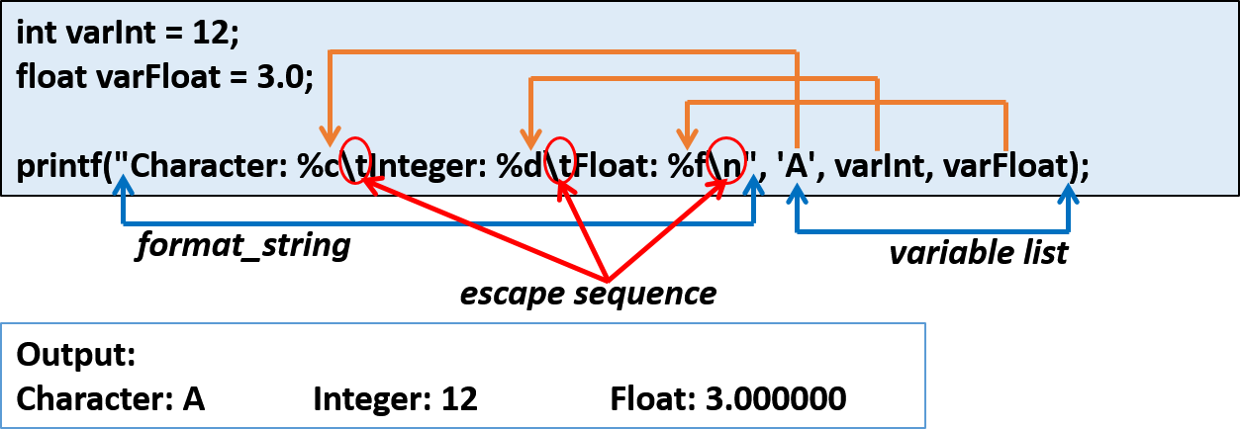

Examples:

int size = 7;

float average = 80.5; printf("Welcome!\n"); printf("a=%d b=%d\n\n", 3, size);

printf("Test Results:\nAverage=%.2f", average);

### Format Specifiers

|  |  |  |  |  |
| --- | --- | --- | --- | --- |
| **Format specifier** | **Description** | | | **Supported data types** |
| %c | Character | | | char  unsigned char |
| %d | Signed Integer | | | short  unsigned short int  long |
| %e or %E | Scientific notation of float values | | | float double |
| %f | Floating point | | | float |
| %g or %G | Similar as %e or %E | | | float double |
| %i | Signed Integer | | | short  unsigned short int  long |
| %l or %ld or %li | Signed Integer | | | long |
| %lf | Floating point | | | double |
| %Lf | Floating point | | | long double |
| %lu | Unsigned integer | | | unsigned int unsigned long |
| %o | Octal representation of Integer. | | | short  unsigned short int  unsigned int  long |
| %p | Address of pointer to void | void * |  | void * |
| %s | String | | | char * |
| %u | Unsigned Integer | | | unsigned int unsigned long |
| %x or %X | Hexadecimal representation of Unsigned Integer | | | short  unsigned short int  unsigned int long |
| %% | Prints % character | | |  |

Escape Sequences

|  |  |  |
| --- | --- | --- |
| Escape  Sequence | Name | Description |
| \a | Alert | Sounds a beep |
| \b | Back space | Backs up 1 character |
| \f | Form feed | Starts a new screen of page |
| \n | New line | Moves to the beginning of next line |
| \r | Carriage return | Moves to the beginning of current line |
| \t | Horizontal tab | Moves to the next tab position |
| \v | Vertical tab | Moves down a fixed amount |
| \\ | Back slash | Prints a back slash |
| \’ | Single quotation | Prints a single quotation |
| \” | Double quotation | Prints a double quotation |
| \? | Question mark | Prints a question mark |

**References**

* Tan, H.H., and T.B. D’Orazio. *C Programming for Engineering & Computer Science*. USA: WCB McGRaw-Hill. 1999. Print.
* Hock-Chuan, Chua. *C programming Tutorial*. Programming notes, n.d. Web. 23 Jan, 2017.<https://www3.ntu.edu.sg/home/ehchua/programming/index.html>
* *BSC btechsmartclass*. n.d. Web. 23 Jan, 2017.<http://www.btechsmartclass.com/CP/computer-languages.htm>